- Mostrar los actores y las películas en las que participan.
SELECT*
FROM actor a
INNER JOIN film_actor fa ON a.actor_id = fa.actor_id
INNER JOIN film f ON fa.film_id = f.film_id;
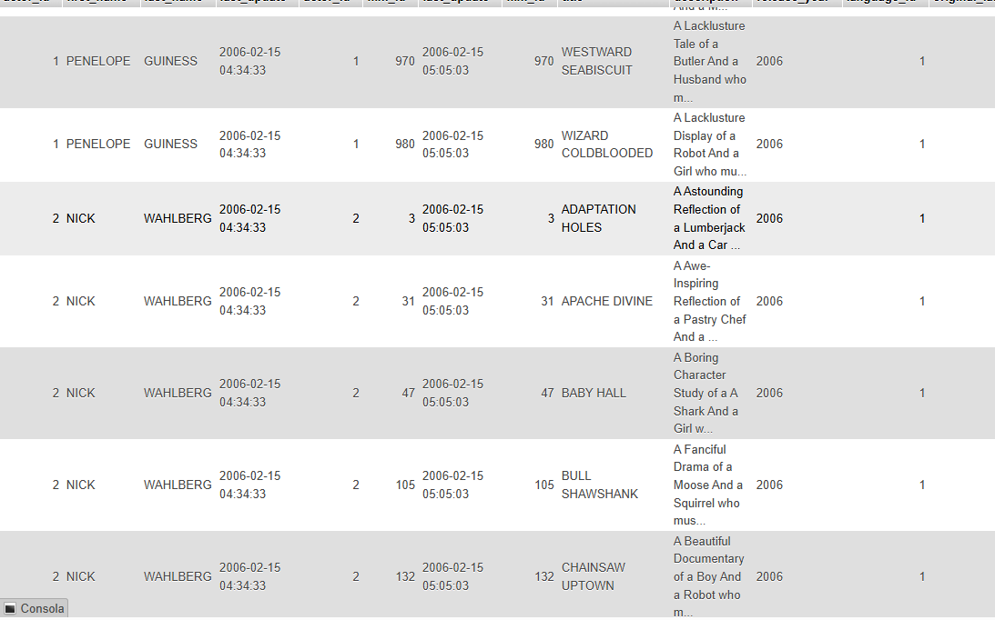

- Mostrar las películas ordenadas de mayor a menor duración
SELECT title AS película, length AS duración
FROM film
ORDER BY length DESC;
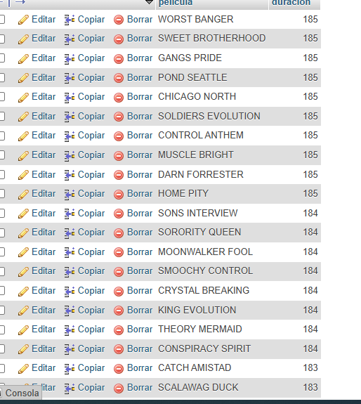

- Mostrar las películas que pertenecen a la categoría “action”.
SELECT f.title AS película, c.name AS categoria
FROM film f
INNER JOIN film_category fc ON f.film_id = fc.film_id
INNER JOIN category c ON fc.category_id = c.category_id
WHERE c.name = ‘Action’;

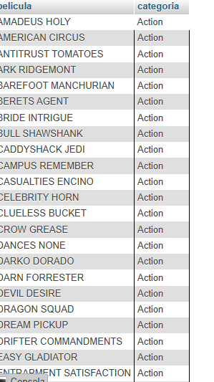

- Mostrar los clientes con la cantidad de rentas que ha realizado.
SELECT c.first_name AS nombre, c.last_name AS apellido, count(r.rental_id) AS total_rentas
FROM customer c
INNER JOIN rental r ON c.customer_id = r.customer_id
GROUP BY c.customer_id, c.first_name, c.last_name;
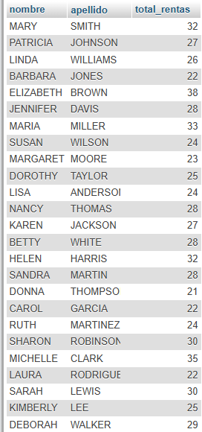

- Mostrar los pagos realizados por cada cliente.
SELECT c.first_name AS Nombre, c.last_name AS Apellido, p.amount AS pago
FROM customer c
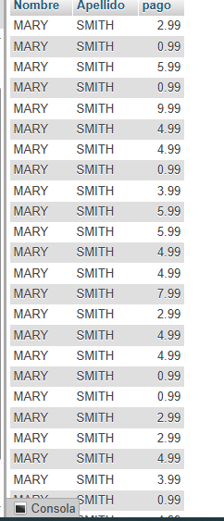
INNER JOIN payment p ON c.customer_id = p.customer_id;

- Mostrar cuantos clientes hay por tienda.
SELECT store_id AS tienda, count(customer_id) AS total_clientes
FROM customer
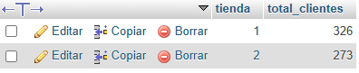
GROUP BY store_id;

- Contar cuantos actores hay en cada película.
SELECT f.title AS película, count(fa.actor_id) AS total_actores
FROM film f
INNER JOIN film_actor fa ON f.film_id = fa.film_id
GROUP BY f.title;
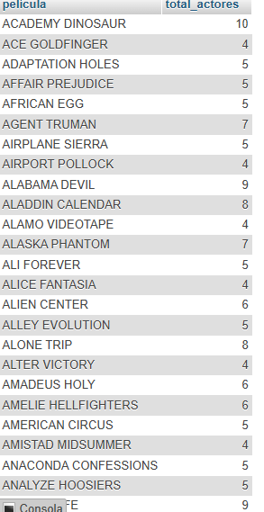

- Mostrar las 5 películas más rentadas.
SELECT f.title AS película, count(r.rental_id) AS total_rentas
FROM film f
INNER JOIN inventory i on f.film_id = i.film_id
INNER JOIN rental r ON i.inventory_id = r.inventory_id
GROUP BY f.film_id, f.title
ORDER BY total rentas DESC
LIMIT 5;
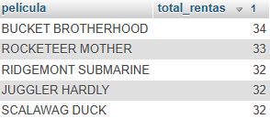

- Mostrar cuantas películas hay por idioma.
SELECT I.name AS idioma, count(f.film_id) AS total_peliculas
FROM language I
INNER JOIN film f ON I.language_id = f.language_id
GROUP BY I.name;
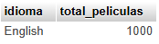

- Mostrar el total de rentas realizadas por cada tienda.
SELECT s.store_id AS tienda, count(r.rental_id) AS total_rentas
FROM store s
INNER JOIN staff st ON s.store_id = st.store_id
INNER JOIN rental r ON st.staff_id = r.staff_id
GROUP BY s.store_id
